 

Bulletin of

ROTARY CLUB OF TRIVANDRUM NORTH

**President: Rtn Ashok P Menon Secretary Rtn PP Sivaramakrishnan**

**FEBRUARY**-**PEACE & CONFLICT PEVENTION / RESOLUTION**

# President’s message

February was also a month of lot of happenings. We had our much awaited District Conference on 6th and 7th. It was well organized with lots of good speakers and fun and frolic in the evening. 19 of our members registered but a few of them could not make it because of other engagements. I thank all Rotarians for participating in very large numbers in the District Conference.

We have successfully completed three more two star WinS projects- Jagathy, Mudavanmugal and Kunnupuzha- which were inaugurated by Rtn Dr Vavani

February is designated as Peace & Conflict Prevention/ Resolution. It was earlier designated as World understanding and Peace. February 23rd is Rotary’s Birthday. This is the **111th** birthday of Rotary and let us wish Rotary Many more centuries of service to humanity.

Many of our Rotarians are also celebrating their birthdays in February. But one Rotarian, Dr B K Easwara Pillai celebrates his birth day every leap year- on 29th February. He celebrated this once in four year event with all family members of the club by hosting a dinner. We wholeheartedly thank Rtn Dr Easwara Pillai for this noble gesture and wish him a happy and healthy life.

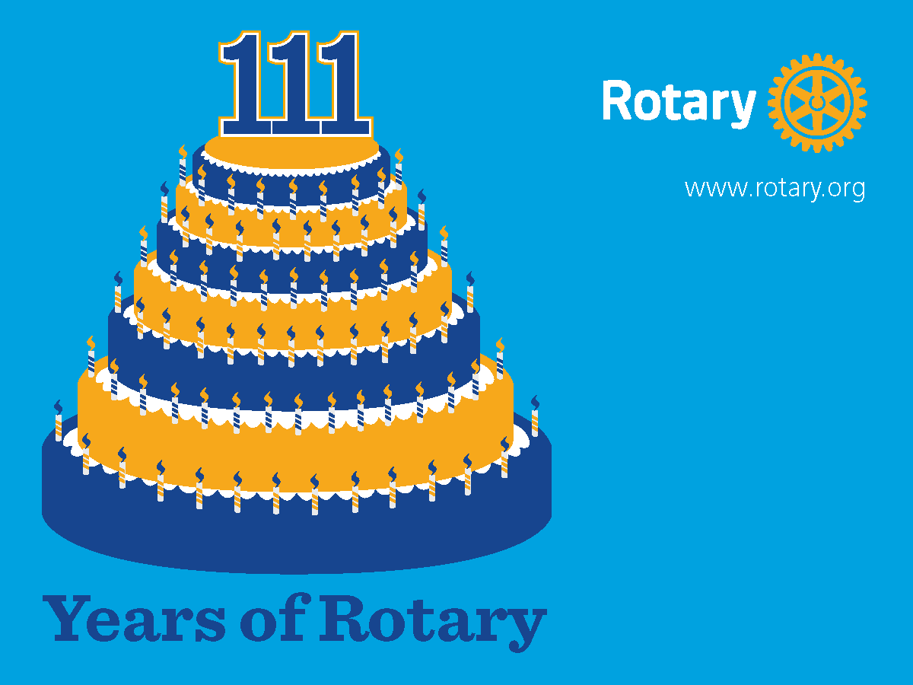

# Peace and Conflict Prevention/Resolution

# Sixty million people are displaced by armed conflict or persecution, and 90 percent of armed-conflict casualties are civilians, half of them children. Through service projects, fellowships, and other Rotary-sponsored campaigns, members train adults and young leaders to prevent and mediate conflict, and aid refugees who have fled dangerous areas. Members also pursue projects to address the underlying structural causes of conflict, including poverty, inequality, ethnic tension, lack of access to education, and unequal distribution of resources.

### What are Rotary Peace Fellowships?



Each year, Rotary selects up to 100 individuals from around the world to receive fully funded academic fellowships at one of our peace centers. These fellowships cover tuition and fees, room and board, round-trip transportation, and all internship and field-study expenses.

In just over a decade, the Rotary Peace Centers have trained more than 900 fellows for careers in peace building. Many of them go on to serve as leaders in national governments, NGOs, the military, law enforcement, and international organizations like the United Nations and World Bank.

Two types of peace fellowships are available.

#### Master's degree

We offer master’s degree fellowships at premier universities in fields related to peace and conflict prevention and resolution. Programs last 15 to 24 months and require a practical internship of two to three months during the academic break. Each year, we award up to 50 master’s degree fellowships at these institutions:

* [Duke University and University of North Carolina at Chapel Hill](http://www.rotarypeacecenternc.org/), USA
* [International Christian University](http://subsite.icu.ac.jp/rotary/index.htm), Japan
* [University of Bradford](http://www.brad.ac.uk/acad/peace/rotary/), England
* [University of Queensland](http://www.polsis.uq.edu.au/rotary/index.html), Australia
* [Uppsala University](http://www.pcr.uu.se/education/uppsala_rotary_peace_center/), Sweden

#### Professional development certificate

For experienced professionals working in peace-related fields who want to enhance their professional skills, we offer a three-month program in peace and conflict prevention and resolution at [Chulalongkorn University](http://www.rotarychula.org/) in Thailand .This program incorporates two to three weeks of field study. We award up to 50 certificates each year.

**HOOKED TO THE HANDSET**

Mobile phone addiction is akin to any other substance addiction. It has been shown that many compulsive behaviors light up the same pleasure centers in the brain in almost in the same way as drug or alcohol dependencies. Mobile phone addiction may soon get included in the Bible for psychiatric illness , the Diagnostic and Statistical Manual of Mental Disorders.

**NOMOPHOBIA** has been recently accepted as aphobic disorder where people have a fear of being in a place where there is no mobile phone network as they may miss something important. Not being connected to a smart phone can create panic in some people and it is fast becoming as another technology- related emotional problem called **FOMO** (Fear of Missing Out). FOMO is not only about e-mails but also because of the various networking forums that are now easily accessible via smart phones. FOMO can turn into an unhealthy obsession.

**Characteristics of overuse and addiction**

1. You check your phone every 10 seconds, in the loo, at the dining table, and at store checkouts.
2. You think that a message has arrived when it has not (called textaphrenia) or you get panic attacks for not receiving or sending text messages (texiety)
3. You develop a phantom phone syndrome. You think your phone is buzzing or ringing, but there is really no call or text.
4. You never switch it off, make sure obsessively that it’s in your pocket or bag. Your heart skips a beat if you don’t find it near you.
5. You have started sleeping with the phone next to you. You check it last thing at night and reach for it first thing in the morning.
6. People have started saying that you’re on it too much. You get defensive, claiming you expect calls or mails from office. Or you check your phone covertly.
7. You are convinced that you can do two things at the same time: text and listen, text and walk, talk and drive.

**A few preventive strategies**

Accept FOMO as something natural rather than beating yourself up for being envious of what others have and you have not. Watch yourself. The fun or other positives that you are missing out might not be as huge as you imagine it to be. “Act as if” you are moving away from FOMO. Live in the present. Budget your time and allot only a part of your day to checking social networking areas. Turn of the internet in your cellphone in progressive amounts. First for 15 minutes, then 30 minutes and go up to 5 hours with out internet. Turn off your cellphone when you go to bed and avoid checking messages in the night and as soon as you wake up.

**One Line Humor**

[1] Regular naps prevent old age, especially if you take them while driving.

[2] Having one child makes you a parent; having two you are a referee.

[3] Marriage is a relationship in which one person is always right and the other is the husband!

[4] I believe we should all pay our tax with a smile. I tried - but they wanted cash.

[5] A child's greatest period of growth is the month after you've purchased new school uniforms.

[6] Don't feel bad. A lot of people have no talent.

[7] Don't marry the person you want to live with, marry the one you cannot live without, but whatever you do, you'll regret it later.

[8] You can't buy love, but you pay heavily for it.

[9] Bad officials are elected by good citizens who do not vote.

[10] Laziness is nothing more than the habit of resting before you get tired.

[11] Marriage is give and take. You'd better give it to her or she'll take it anyway.

[12] My wife and I always compromise. I admit I'm wrong and she agrees with me.

[13] Those who can't laugh at themselves leave the job to others.

[14] Ladies first. Pretty ladies sooner.

[15] A successful marriage requires falling in love many times, always with the same person.

[16] You're getting old when you enjoy remembering things more than doing them.

[17] It doesn't matter how often a married man changes his job, he still ends up with the same boss.

[18] Real friends are the ones who survive transitions between address books.

[19] Saving is the best thing. Especially when your parents have done it for you.

[20] Wise men talk because they have something to say; fools talk because they have to say something

**Enhance your leadership skills in the Rotary Learning Center**

Professional development is right at your fingertips with the Rotary Learning Center, which offers members a range of interactive courses on navigating Rotary's online tools and developing leadership skills to prepare for new Rotary roles.

Anyone with a My Rotary account can take a free course in the Learning Center. Among the many courses available are How to Run a Webinar, How to Propose Legislation, Rotary Club Central Resources, and role-specific selections.

Get started by finding the Learning Center under the **LEARNING & REFERENCE** tab on Rotary.org.

If you are already registered on the site, you will have a profile. If not, it's easy to create an account. From the **MY PROFILE** tab, you can modify your profile, find announcements about new and upcoming courses, and join a community to discuss what you're learning.

A great way to begin is by viewing the How to Navigate the Learning Center video tutorial, which covers what's available and how to make the most of it.

The center's catalog allows users to browse a list of subjects or see a complete rundown of all the courses offered. When registering for a course, you can either proceed to the material immediately or save it for later, returning to it from the **MY COURSES** tab.

Course material is provided in a variety of formats, including PDF and Word documents, interactive e-learning modules, and videos. Only some e-learning modules have audio, but all of them enable you to decide when to go on to the next screen.

A bar at the top of the screen marks your progress through each course. And a snapshot of all the courses you have registered for is available with the **COURSE HISTORY** tab, which also enables you to print a certificate once you have completed all requirements. Some district leaders require attendees at in-person training sessions to bring a printed certificate to ensure that they review relevant material before their session.

"This is a great way to use the center," says Adam Arents, Rotary's supervisor of learning technology. "It's better preparation than emailing a list of documents and saying, 'Please read these.' "

If your district sponsors fellowships or scholarships, you'll want to point recipients toward the Orientation for Scholars, Vocational Training Teams, and Peace Fellows course.

One of the most popular courses is Strengthen Rotary, which teaches members to incorporate Rotary values into everyday activities. The Rotary Club Central Resources course, another popular offering, helps members set goals and improve membership information.

For the first time, a required course has been added for representatives attending the 2016 Council on Legislation.

And a committee of British trainers, working on behalf of Rotary International in Great Britain & Ireland (RIBI), has developed a course covering RIBI policies and practices. The team is preparing other courses for a more global audience.

DGN Nomination

In the Nominating Committee meeting held on 15th February 2016 at Kottayam Rtn E K Luke of Rotary Club of Vaikom was unanimously elected as District Governor Nominee. He will assume office as District Governor in the Rotary Year 2018-19



**Birth Days**

3rd Sreelatha ann of Chandramohan

8th Priya annet of Dr Madhava Kaimal

10th Thanay annet of Mahesh

12th S Perumal Pillai

13th Sreehari annet of Mohanan Nair

15th Feb Rtn G M Pillai

16th Sreeram annet of Sethunath

19th Aravind annet of K N G Kaimal

25th Dr Sandhya annet of Sivan Kutty

27th Remya annet of K P Thomas

29th Dr Easwara Pillai